7.49: a) 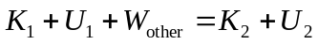
Let point 1 be point A and point 2 be point B. Take 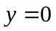 at point B.
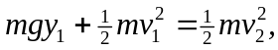 with 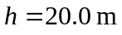 and 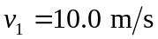
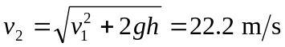
b) Use 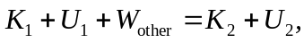 with point 1 at B and point 2 where the spring has its maximum compression x.
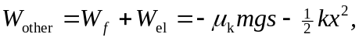 with 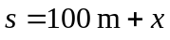
The work-energy relation gives 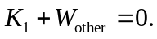
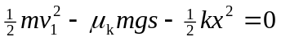
Putting in the numerical values gives 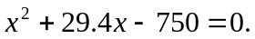 The positive root to this equation is 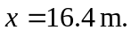
b) When the spring is compressed 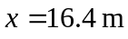 the force it exerts on the stone is 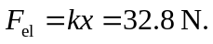 The maximum possible static friction force is
The spring force is less than the maximum possible static friction force so the stone remains at rest.

